**DAILY ONLINE ACTIVITIES SUMMARY**

|  |  |  |  |  |  |  |  |  |
| --- | --- | --- | --- | --- | --- | --- | --- | --- |
| **Date:** | **05/06/2020** | | | | | **Name:** | **NAIPUNYA VINOD NAIK** | |
| **Sem & Sec** | **IV SEM & A SECTION** | | | | | **USN:** | **4AL18CS050** | |
| **Online Test Summary** | | | | | | | | |
| **Subject** | | **N/A** | | | | | | |
| **Max. Marks** | | **N/A** | | **Score** | | | **N/A** | |
| **Certification Course Summary** | | | | | | | | |
| **Course** | **INTRODUCTION TO DIGITAL MARKETING** | | | | | | | |
| **Certificate Provider** | | | **GOOGLE** | | **Duration** | | | **40 HRS** |
| **Coding Challenges** | | | | | | | | |
| **Problem Statement:1)** **Write a Java Program to find the duplicate characters in a string.** | | | | | | | | |
| **Status: EXECUTED** | | | | | | | | |
| **Uploaded the report in Github** | | | | | **YES** | | | |
| **If yes Repository name** | | | | | <https://github.com/naipunya-naik/lockdown-coding/blob/master/JAVA%20CODING/DuplicateCharacters_05-06-2020.java> | | | |
| **Uploaded the report in slack** | | | | | **YES** | | | |

Online Test Details: (Attach the snapshot and briefly write the report for the same).

NO TEST CONDUCTED

Certification Course Details: (Attach the snapshot and briefly write the report for the same).

CERTIFICATION COURSE NAME:- INTRODUCTION TO DIGITAL MARKETING

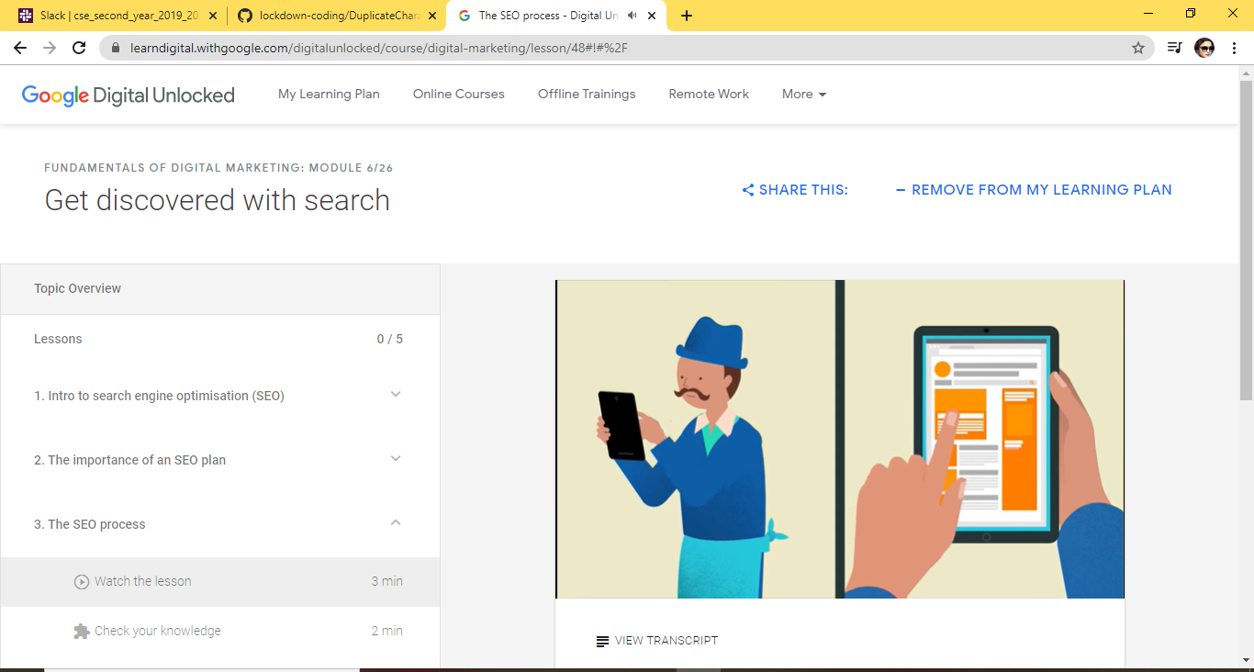

TOPICS LEARNT ON 05 JUNE 2020:-

* Lessons
* 1. Intro to search engine optimisation (SEO)
* 2. The importance of an SEO plan
* 3. The SEO process
* 4. How to choose keywords
* 5. Setting realistic SEO goals

Coding Challenges Details: (Attach the snapshot and briefly write the report for the same).

PROBLEM STATEMENT:- **Write a Java Program to find the duplicate characters in a string.**

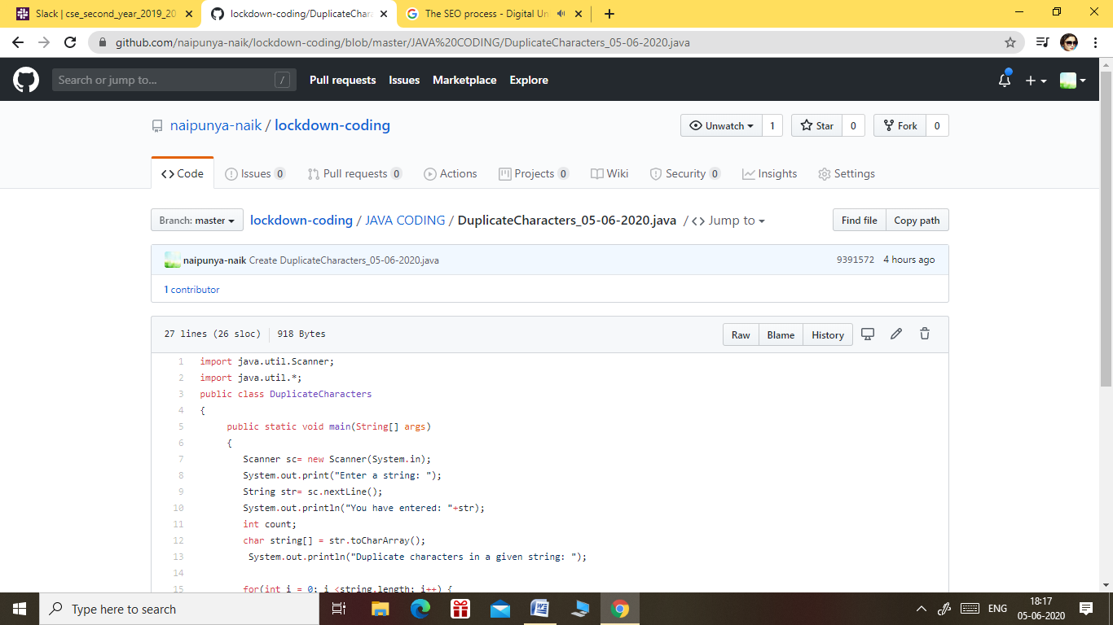

GITHUB REPOSITORY LINK:-

<https://github.com/naipunya-naik/lockdown-coding/blob/master/JAVA%20CODING/DuplicateCharacters_05-06-2020.java>